Cameron Mikel

Student id: 4400115752

A6-2: Git Setup with Basic Node Project

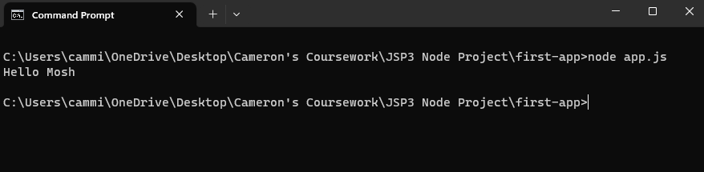

GitHub Link

<https://github.com/CamMikel91/JSP3-Node-Project.git>